Chapter 2, Problem 82.

The pin diagram of a resistance array is shown in Fig. 2.141. Find the equivalent resistance between the following:

(a) 1 and 2 (b) 1 and 3 (c) 1 and 4

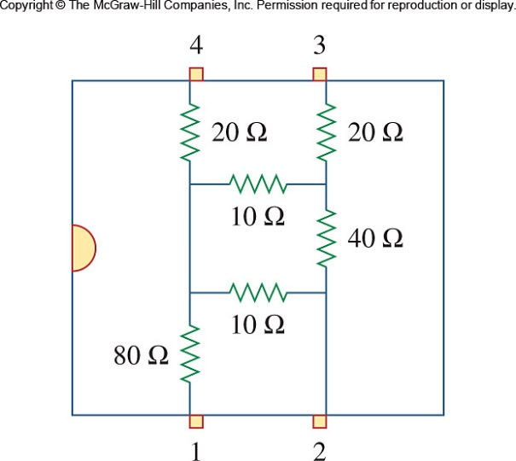

Figure 2.141
For Prob. 2.82.

